One way to serialize a binary tree is to use **preorder traversal**. When we encounter a non-null node, we record the node's value. If it is a null node, we record using a sentinel value such as '#'.

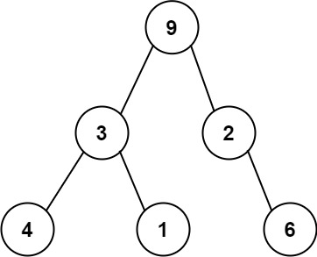

For example, the above binary tree can be serialized to the string "9,3,4,#,#,1,#,#,2,#,6,#,#", where '#' represents a null node.

Given a string of comma-separated values preorder, return true if it is a correct preorder traversal serialization of a binary tree.

It is **guaranteed** that each comma-separated value in the string must be either an integer or a character '#' representing null pointer.

You may assume that the input format is always valid.

* For example, it could never contain two consecutive commas, such as "1,,3".

**Note:**You are not allowed to reconstruct the tree.

**Example 1:**

**Input:** preorder = "9,3,4,#,#,1,#,#,2,#,6,#,#"

**Output:** true

**Example 2:**

**Input:** preorder = "1,#"

**Output:** false

**Example 3:**

**Input:** preorder = "9,#,#,1"

**Output:** false

**Constraints:**

* 1 <= preorder.length <= 104
* preoder consist of integers in the range [0, 100] and '#' separated by commas ','.